Stored Procedures, Functions, and Triggers Implementation
This section presents the stored procedures, functions, and triggers implemented in the FlexAir database. Screenshots are taken from the Supabase SQL editor, and each database object is briefly explained with its role in the system.
In PostgreSQL, stored procedures are implemented as PL/pgSQL functions. Therefore, the procedures in this system are defined using CREATE FUNCTION statements and are responsible for executing core business logic.

Stored Procedures
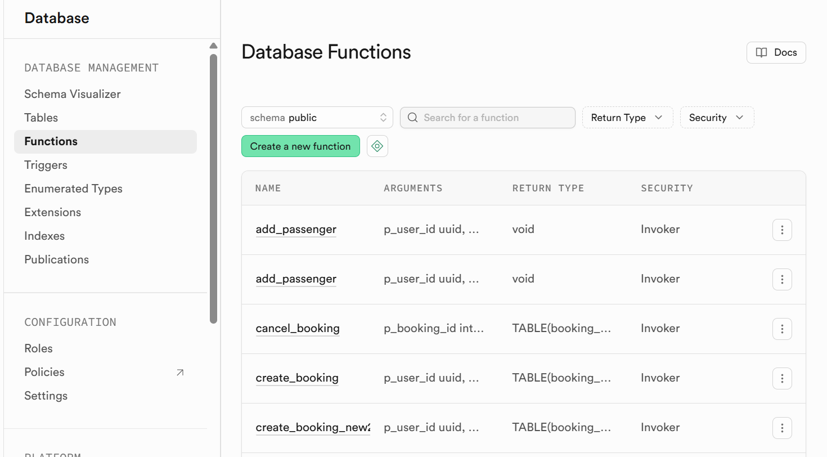

add_passenger Procedure
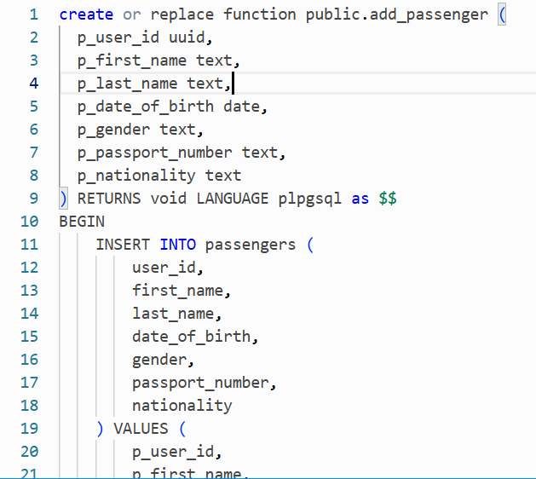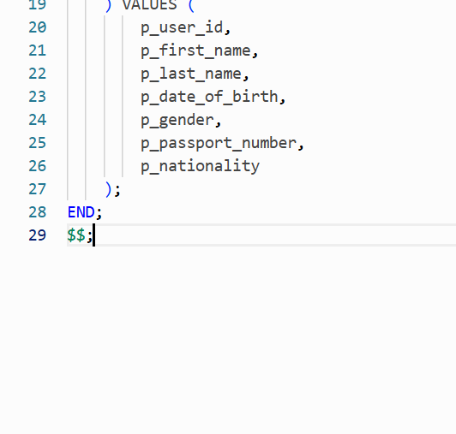
Explanation:
This procedure inserts a new passenger record into the passengers table.
Each passenger is linked to a specific authenticated user through user_id, ensuring data ownership and security.
It is used when a customer adds passenger information before making a booking.

update_passenger Procedure
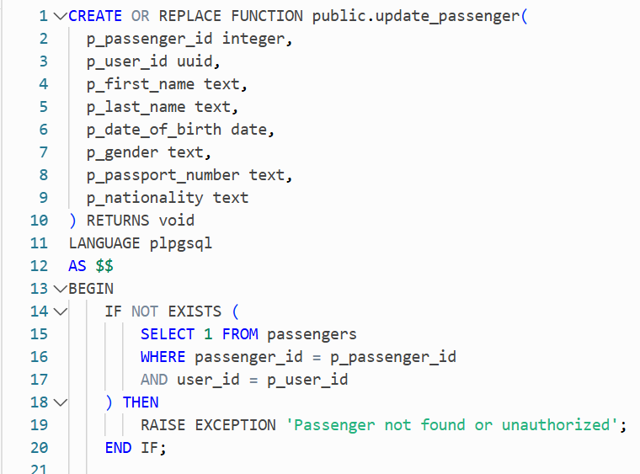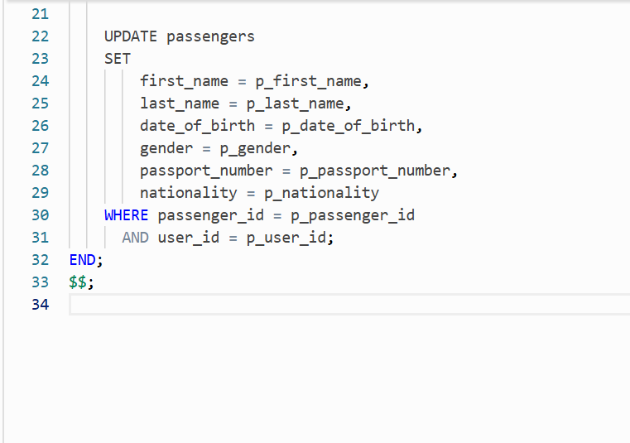
Explanation:
This procedure updates existing passenger details such as name, date of birth, nationality, and passport information.
Before updating, it verifies that the passenger belongs to the requesting user, preventing unauthorized modifications.

1.3 create_booking Procedure
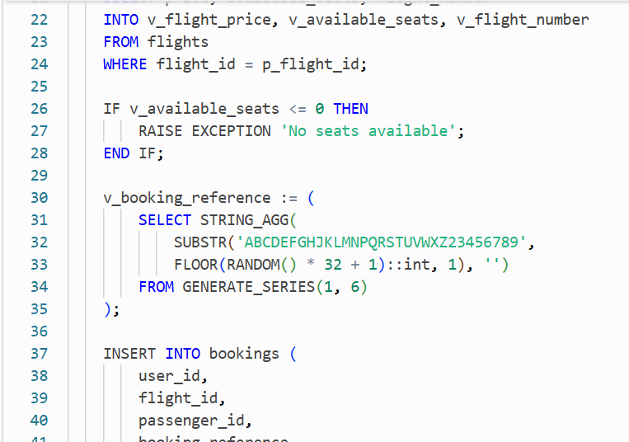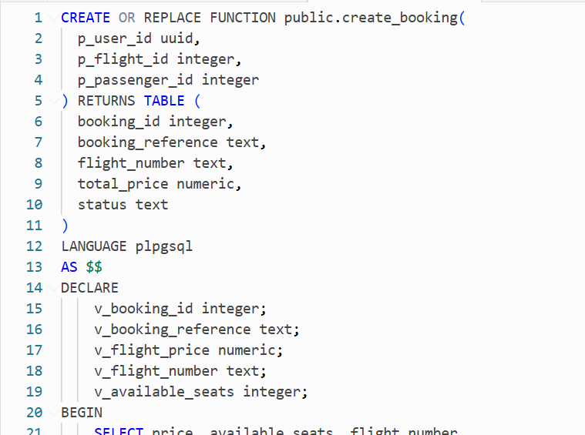
Explanation:
This procedure creates a new flight booking for a passenger.
It checks seat availability, generates a unique booking reference (PNR), inserts the booking record, and decreases the available seats of the selected flight.
The procedure returns booking details to be displayed as confirmation in the user interface.

1.4 cancel_booking Procedure
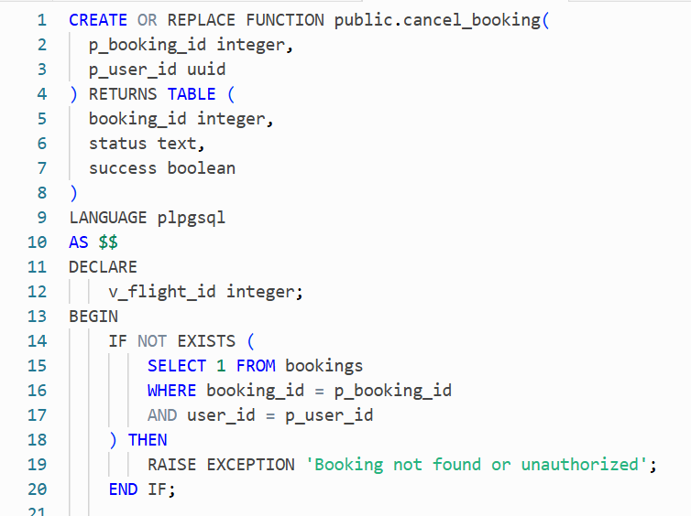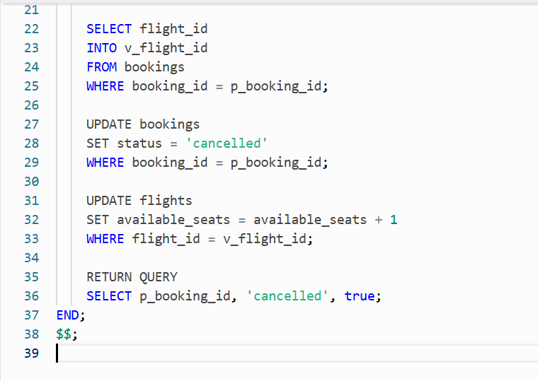
Explanation:
This procedure cancels an existing booking after verifying user ownership.
The booking status is updated to cancelled, and the corresponding seat is restored to the flight’s available seats.

Stored Functions
We have more than 7 functions. Since we don’t have that much time to present all the codes to you, we put 2-3 samples of functions for you .
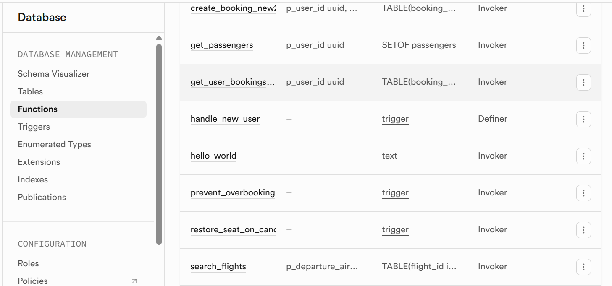

2.1 get_passengers Function
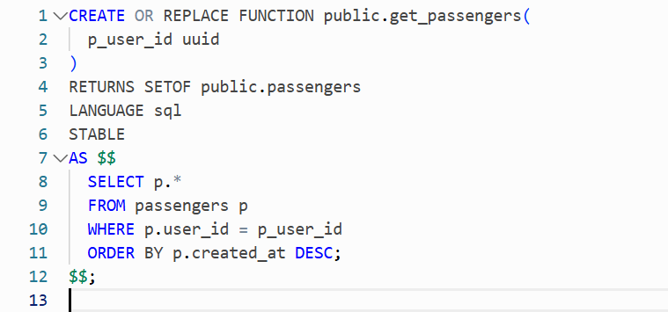
Explanation:
This function retrieves all passengers associated with a specific user.
It is used to populate passenger lists in the application when selecting a passenger for booking.

2.2 get_user_bookings Function
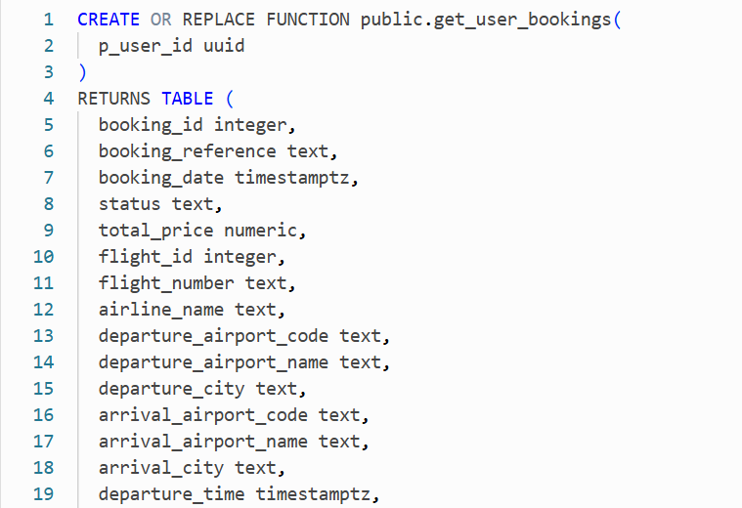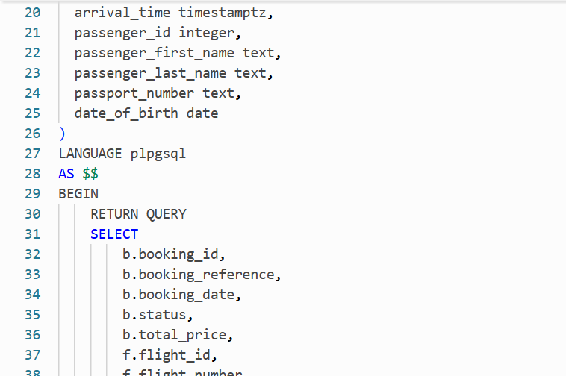
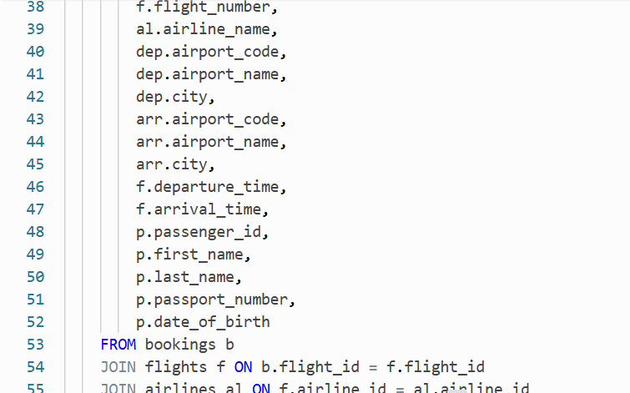
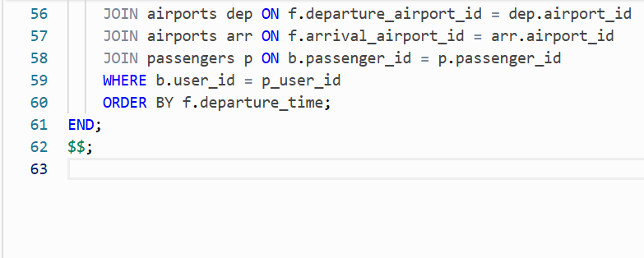
Explanation:
This function returns a complete booking history for the logged-in user.
It joins bookings, flights, airlines, airports, and passengers to provide detailed booking information in a single query.

2.3 search_flights Function
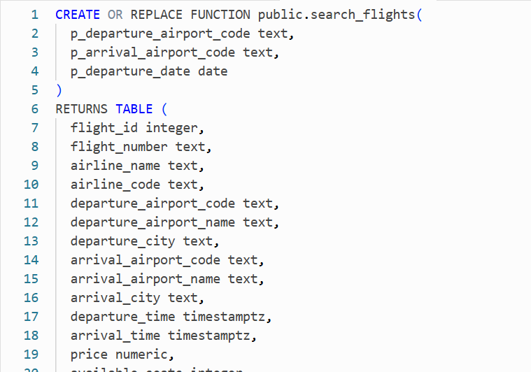
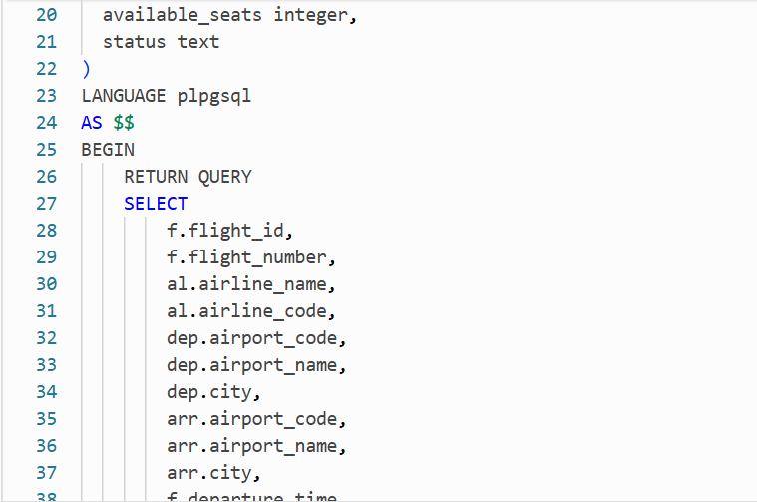
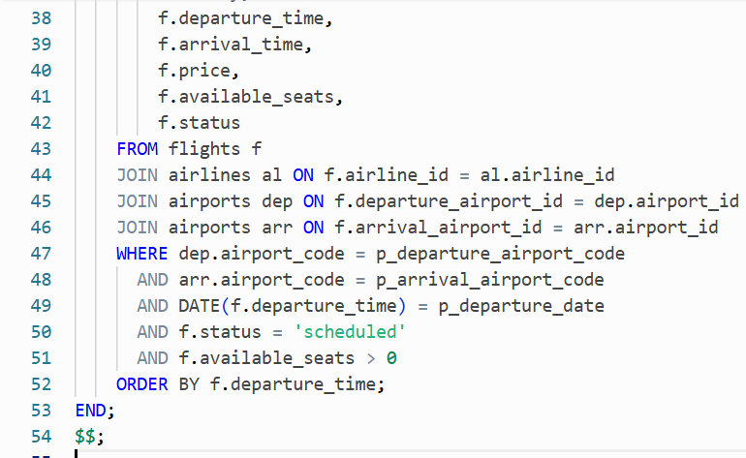
Explanation:
This function searches for available flights based on departure airport, arrival airport, and departure date.
Only scheduled flights with available seats are returned, sorted by departure time.

Trigger Functions
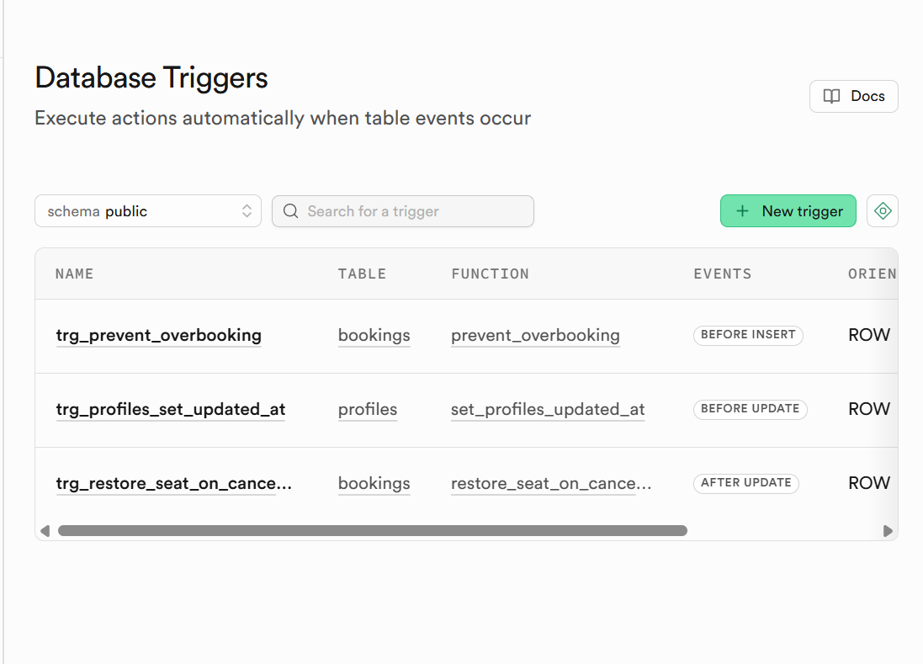

3.1 prevent_overbooking Trigger Function
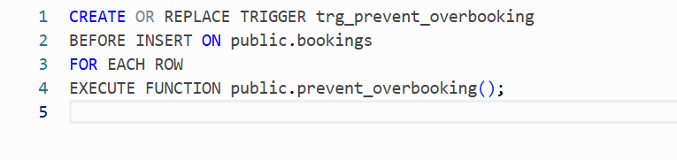
Explanation:
This trigger function checks seat availability before inserting a new booking.
If no seats are available, the insertion is blocked, preventing overbooking at the database level.

3.2 restore_seat_on_cancellation Trigger Function
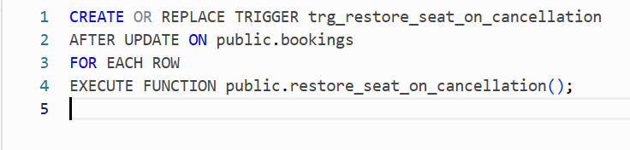
Explanation:
This trigger function automatically restores a seat when a booking status changes to cancelled.
It ensures seat consistency without relying on application logic.

3.3 profiles_set_updated_at Trigger Function
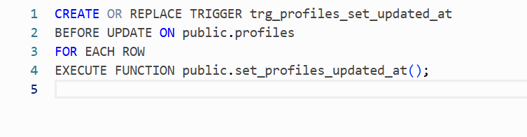
Explanation:
This trigger function updates the updated_at timestamp whenever a profile record is modified.
It helps maintain accurate tracking of profile changes.

